Oracle Database Administration Services
KE_Archive missing error resolution

Submitted to



By



CIS, Wipro Limited

Document Details

Project Name | Innogy SE
Account | CIS
IT Component/Application Title | KE_Archive missing error resolution
Current Version | 1.5
List of Contributors | Kamlesh Sawant , Chetan Patel , Saurabh Nigam , Abhishek Kansal , Jiten Pansara
Customer Contact Information

Version History
(All revisions made to this document must be listed in chronological order. All revisions must be approved. Review and Approval can be done by an internal source or by the customer)
Version | Date of Revision | Description | Author | Reviewed By | Approved By
1.0 | 29-08-2015 | Intial Draft | Chetan Patel | Chetan Patel | Mahesh Keshatwar
1.1 | 04-06-2015 | Document Completed | Chetan Patel | Chetan Patel | Mahesh Keshatwar
1.2 | 21-08-2016 | Updated document to standard format | Kamlesh Sawant | Saurabh Nigam | Mahesh Keshatwar
1.3 | 17-05-2017 | Wipro and Innogy Logo changed | Jiten Pansara | Saurabh Nigam | Mahesh Keshatwar
1.4 | 15-11-2017 | Updated document to Wipro Standard format with header and footer | Abhishek Kansal | Jiten Pansara | Yogesh Desai
1.5 | 20-12-2018 | Updated the content | Abhishek Kansal | Jiten Pansara | Santosh Badiger

Short Description:
Archive missing error while running backup.
Problem Description:
Archive missing error while running INC0, INC1 or archive backup error.
You will get ORA-19625 in log file of RMAN.
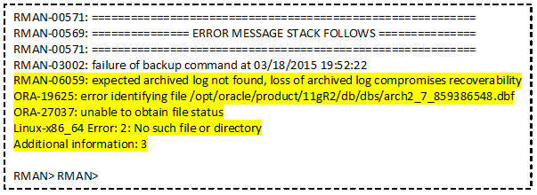
Root cause:
Archive log might be missed from the archive location or Catalog database don’t have archive details.
Workaround:
To resolve the issue, follow below steps:
- Login to the server.
- Check rman backup log(/oracle/rman/log)
- Connect to RMAN using below command
Rman target /
- Connect to catalog database. For ex:
Connect catalog rmanukrmanp/******@rmanp;
- Crosscheck archivelog all;
- Delete expired archivelog all;
It will prompt you for Yes/No: Enter Yes

- Run the backup again using below command
Nohup /oracle/rman/bin/rmanc.sh <DB_SID> backup_arch.rcv &

